Client Intake Form – Family Wholistic Wellness
Personal Information:

Name_____________________________________ Phone (Day)__________________ Phone (Eve)__________________
Address____________________________________________________________________________________________
City/State/Zip__________________________________________________________________________
Email____________________________________ Date of Birth_______________ Occupation______________________
Emergency Contact___________________________________________________ Phone__________________________

The following information will be used to help plan safe and effective massage sessions.
Please answer the questions to the best of your knowledge.

Date of Initial Visit_________________________
1. Have you had a professional massage before? Yes No
If yes, how often do you receive massage therapy?__________________________________________________
2. Do you have any difficulty lying on your front, back, or side? Yes No
If yes, please explain___________________________________________________________________________
3. Do you have any allergies to oils, lotions, or ointments? Yes No
If yes, please explain___________________________________________________________________________
4. Do you have sensitive skin? Yes No
5. Are you wearing contact lenses ( ) dentures ( ) a hearing aid ( ) ?
6. Do you sit for long hours at a workstation, computer, or driving? Yes No
If yes, please describe__________________________________________________________________________
7. Do you perform any repetitive movement in your work, sports, or hobby? Yes No
If yes, please describe__________________________________________________________________________
8. Do you experience stress in your work, family, or other aspect of your life? Yes No
If yes, how do you think it has affected your health?_________________________________________________
muscle tension ( ) anxiety ( ) insomnia ( ) irritability ( ) other
9. Is there a particular area of the body where you are experiencing tension, stiffness, pain
or other discomfort? Yes No
If yes, please identify__________________________________________________________________________
10. Do you have any particular goals in mind for this massage session? Yes No
If yes, please explain___________________________________________________________________________

Circle any specific areas you would like the
massage therapist to concentrate on during this session:
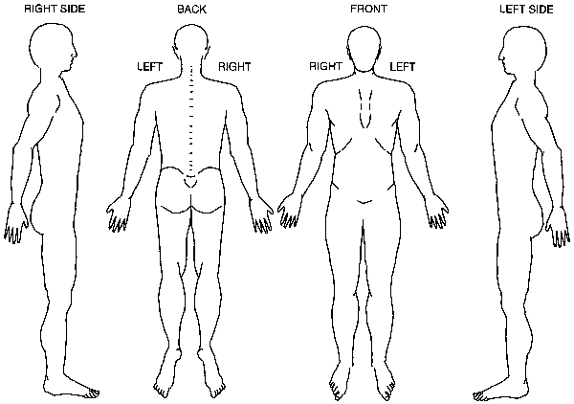

Medical History
In order to plan a massage session that is safe and effective,
I need some general information about your medical history.

11. Are you currently under medical supervision? Yes No
If yes, please explain___________________________________________________________________________
12. Do you see a chiropractor? Yes No If yes, how often?__________________________________________________
13. Are you currently taking any medication? Yes No
If yes, please list______________________________________________________________________________
14. Please check any condition listed below that applies to you:
( ) contagious skin condition ( ) phlebitis
( ) open sores or wounds ( ) deep vein thrombosis/blood clots
( ) easy bruising ( ) joint disorder/rheumatoid arthritis/osteoarthritis/tendonitis
( ) recent accident or injury ( ) osteoporosis
( ) recent fracture ( ) epilepsy
( ) recent surgery ( ) headaches/migraines
( ) artificial joint ( ) cancer
( ) sprains/strains ( ) diabetes
( ) current fever ( ) decreased sensation
( ) swollen glands ( ) back/neck problems
( ) allergies/sensitivity ( ) fibromyalgia
( ) heart condition ( ) TMJ
( ) high or low blood pressure ( ) carpal tunnel syndrome
( ) circulatory disorder ( ) tennis elbow
( ) varicose veins ( ) pregnancy
( ) atherosclerosis
Please explain any condition that you have marked above ___________________________________________________
____________________________________________________________________________________________________________________________________________________________________________________________________
15. Is there anything else about your health history that you think would be useful for your massage practitioner to
know to plan a safe and effective massage session for you?__________________________________________________
__________________________________________________________________________________________________

Draping will be used during the session – only the area being worked on will be uncovered.
Clients under the age of 17 must be accompanied by a parent or legal guardian during the entire session.
Informed written consent must be provided by parent or legal guardian for any client under the age of 17.

I,_____________________________________________ (print name) understand that the massage I receive is provided
for the basic purpose of relaxation and relief of muscular tension. If I experience any pain or discomfort during this
session, I will immediately inform the therapist so that the pressure and/or strokes may be adjusted to my level of
comfort. I further understand that massage should not be construed as a substitute for medical examination,
diagnosis, or treatment and that I should see a physician, chiropractor or other qualified medical specialist for any
mental or physical ailment that I am aware of. I understand that massage therapists are not qualified to perform
spinal or skeletal adjustments, diagnose, prescribe, or treat any physical or mental illness, and that nothing said in
the course of the session given should be construed as such. Because massage should not be performed under
certain medical conditions, I affirm that I have stated all my known medical conditions, and answered all
questions honestly. I agree to keep the therapist updated as to any changes in my medical profile and
understand that there shall be no liability on the therapist’s part should I fail to do so.

Signature of client____________________________________________________ Date___________________________

Signature of Massage Therapist__________________________________________ Date__________________________

