Client Intake Form

Name:_____________________________________ Date:___________________
Address:___________________________________________________________
Home Phone:___________________________ Cell:_________________________
Email:______________________________________________________________
Occupation:_______________________ Employer:_________________________
DOB:________________ Marital Status:______ Single________ Other_________
Name of Spouse/Significant Other:______________________________________
Children’s Names and Ages:___________________________________________
____________________________________________________________________________________
Referred by (Name):__________________________________________________
Please indicate where you are experiencing concerns:
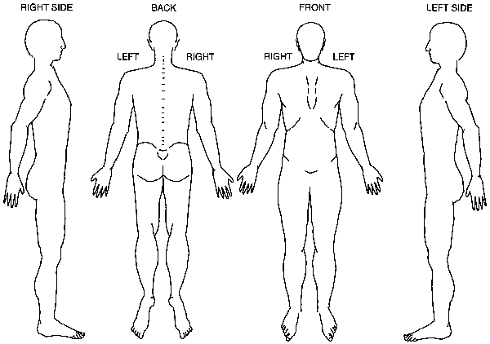

Comments:__________________________________________________________________________________________________________________________________________________________________________________________________________________________________________________________________
Has there been a medical diagnosis? ______yes _______No
If so, by whome?_____________________________________________________
Please explain:_______________________________________________________
______________________________________________________________________________________________________________________________________
Please list all symptoms and indicate ANY medications/supplements, etc that you are using for these symptoms:_________________________________________
_________________________________________________________________________________________________________________________________________________________________________________________________________
Present Symptoms: What is your major complaint or condition you want to improve?_________________________________________________________________________________________________________________________________________________________________________________________________
What have you done or used to get relief?________________________________
______________________________________________________________________________________________________________________________________Do you exercise regularly? _______Yes _______No
Explain:_______________________________________________________________________________________________________________________________Have you ever used alternative methods of support? ______Yes _______No
______________________________________________________________________________________________________________________________________What are your expectations for this visit?_________________________________
___________________________________________________________________

Please list any additional comments or information about your Health & Wellness:
_________________________________________________________________________________________________________________________________________________________________________________________________________
Please list your TOP 5 favorite foods that you eat regularly: _________________________________________________________________________________________________________________________________________________________________________________________________________
What do you typically drink throughout the day:___________________________
___________________________________________________________________
Do you have any known allergies (food or otherwise)? ______________________
___________________________________________________________________
Are you ready for a CHANGE?_______ yes ________ No
Explain:_______________________________________________________________________________________________________________________________
What would hold you back from making changes to lifestyle, nutrition, ect.?
______________________________________________________________________________________________________________________________________What support would you need to have to follow an alternative approach to the body?_________________________________________________________________________________________________________________________________I fully understand that Dawn Cahill is not a medical doctor.
I also understand that Dr. Dawn Cahill and Family Wholistic Wellness LLC does not prescribe, diagnose, treat, cure, prevent or heal disease or make any claims thereof.
Your Signature:______________________________________________________

List of Supplements and Meds you are currently taking:

_____________________________________________
_____________________________________________
_____________________________________________
_____________________________________________
_____________________________________________
_____________________________________________
_____________________________________________
_____________________________________________
_____________________________________________
_____________________________________________
_____________________________________________
_____________________________________________
_____________________________________________
_____________________________________________
_____________________________________________
_____________________________________________
_____________________________________________
_____________________________________________
_____________________________________________
Please List Any Doctors, Chiropractors, or other Practitioners
you are currently seeing:

_____________________________________________
_____________________________________________
_____________________________________________
_____________________________________________
_____________________________________________
_____________________________________________
_____________________________________________
_____________________________________________

